**Assignment – 5**

**Write a brief summary on SCRUM Framework.**

**What is SCRUM Framework:**

The Scrum Framework is an agile methodology used for managing and completing complex projects, typically in software development. It emphasizes iterative progress, flexibility, and collaboration among cross-functional teams. Scrum is based on a set of roles, ceremonies, and artifacts that work together to deliver value in short cycles known as sprints.

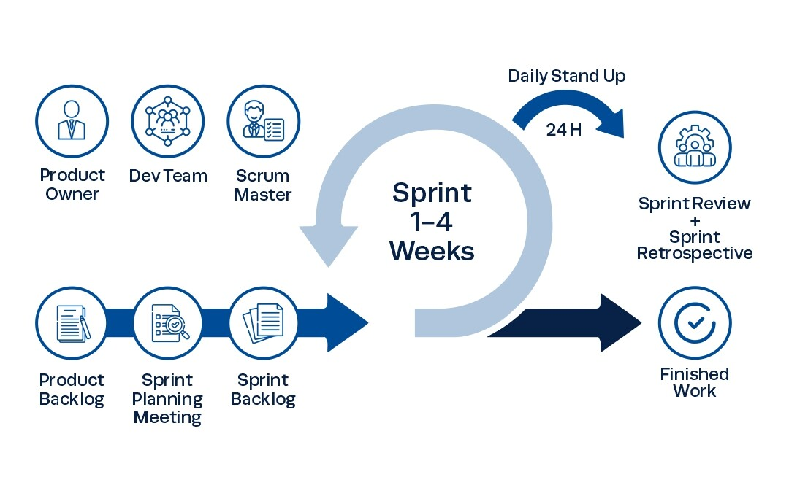

**Key Components of Scrum:**

1. Roles:
   * Product Owner: Responsible for defining the product backlog (list of features, enhancements, bug fixes) and ensuring that the team delivers value to the stakeholders.
   * Scrum Master: Facilitates the Scrum process, ensuring the team adheres to Scrum practices, removes any blockers, and fosters an environment of continuous improvement.
   * Development Team: A cross-functional group that self-organizes to deliver the product increment during each sprint.
2. Ceremonies (Events):
   * Sprint Planning: At the beginning of each sprint, the team plans which backlog items to work on and how they will accomplish the tasks.
   * Daily Scrum (Standup): A short, daily meeting where team members discuss their progress, plans for the day, and any obstacles they face.
   * Sprint Review: At the end of the sprint, the team demonstrates the work completed to stakeholders for feedback.
   * Sprint Retrospective: A reflection meeting where the team discusses what went well, what could be improved, and how they can improve their processes for the next sprint.
3. Artifacts:

In the **Scrum Framework**, **artifacts** are key element that provide transparency and help the Scrum Team organize their work. They are used to represent and track the progress of work, and they guide the team to deliver a successful product.

* + Product Backlog: A prioritized list of tasks, features, or improvements that need to be completed for the product.
  + Sprint Backlog: A list of tasks selected from the product backlog to be completed during a sprint.
  + Increment: The working product that results from the completed tasks in a sprint, which should be in a potentially shippable state.

**Scrum Process:**

* The team works in time-boxed iterations (sprints), usually lasting 1-4 weeks.
* At the end of each sprint, the team delivers a potentially releasable increment of the product, allowing for regular feedback and adjustments.
* Scrum promotes flexibility and continuous improvement, ensuring teams can respond to changes and deliver high-quality products.

In summary, Scrum helps teams work efficiently, adapt to changes quickly, and continuously improve their workflow, making it ideal for projects that require flexibility and iterative development.